STUDY GUIDE CHAPTER 18: Fossil fuels and the Environment p.380-389
Please read the entire selection. Then print this study guide and HANDWRITE your answers to each question in the space provided. DO NOT SKIP THE CRITICAL THINKING or MATH QUESTIONS.

- Coal is the world’s most abundant fossil fuel. How long are global supplies expected to last (at current rates of consumption)?

- Examine figure 18.11. Which three regions of the world contain the largest reserves of coal?

3. Name the 4 classes (ranks) of coal. Which produces the lowest amount of energy but also lowest amount of sulfur?

- Why is low sulfur coal more desirable?

5.. Examine table 18.2. Identify the rank of coal that produces the highest amount of energy but the lowest amount of sulfur?

6. Define the term: reclamation.

7. What is strip mining?

8. Acid mine drainage (AMD) is an environmental issue concerning strip mines in the east coast. Describe how acid mine drainage forms and identify the type of acid formed in this manner.

9. Describe one possible mitigation strategy for minimizing acid mine drainage pollution on surface or ground water.

10. Why is reclamation more difficult in arid regions?

11. A Closer Look 18.2 The Trapper Mine
a. How much coal will be produced from the mine over the 35 period of operation?

- What is meant by the term “overburden”?

- Compare the depth of the overburden to the depth of the coal seams.

- List the 4 steps of coal mining in correct sequence

- Why is reclamation without water possible at the Trapper mine?

- How do miners deal with the problem of sediment pollution from the mine?

- How do miners deal with the problem of air pollution from the mine?

- What are the economic advantage and disadvantage of reclamation of mines?

12. What is mountain top removal?

13. Describe TWO environmental impacts of mountain top removal.

14. Discuss the requirements of the Surface Mining Control and Reclamation Act (SMCRA) of 1977.
15. Underground coal mining carries its own risks. Describe FOUR environmental and/or health hazards of underground mining.

16. Coal, and many other fuels, require fresh water in the generation of electricity.
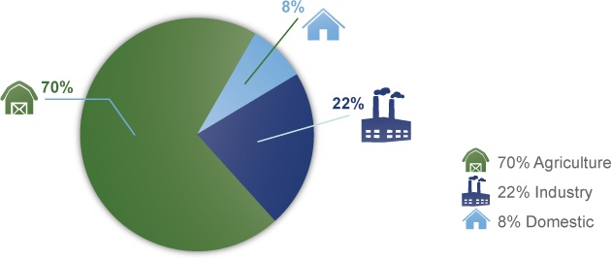
Industrial uses (such as power companies) of water stresses already taxed water systems. Describe TWO uses of freshwater in the coal industry.

17. What types of air pollutants does coal burning add to the air?

18. Scrubbers are used by many coal burning power plants to lower SO₂ emissions as required by the Clean Air Amendments of 1990. Describe how a scrubber works to reduce sulfur emissions.

19. Think: Synthetic gas, Syngas, is one other technology being explored to reduce the sulfur emissions from burning coal. Give one pro and one con for the use of syngas in power plants.

20. Coal is used primarily for generating electricity in the US. However, technology exists to convert the coal to gasoline to use as liquid fuel for automobiles. Identify TWO disadvantages of this technology.

21. Carbon dioxide emissions contribute to the greenhouse effect and global warming. What plans exist for reducing or eliminating the amount of CO₂ emissions from coal burning?

22. Some of the solid waste from coal burning power plants can be used as a resource. Describe TWO potential uses for the slag/sludge waste produced during coal burning.

23. Allowance trading is also known as cap and trade. What is the allowance for SO₂ emissions set by the EPA? What action can companies that are unable to stay within this allowance take to avoid being penalized for polluting?

24. What is oil shale? What environmental impacts are associated with mining oil shale?

25. What is tar sand? Where is the majority of tar sands located?

26. What environmental impacts are associated with tar sands?

27. The combustion of one gallon of gasoline produces about 5 pounds of carbon dioxide (CO₂) as an air pollutant. Two cars are making a trip of 600 miles. The first car gets 20 miles per gallon and the second car gets 30 miles per gallon. Approximately how much less carbon dioxide will be produced by the second car on this trip? Show your work and include units.

